18001 Cowan Suite #K Irvine, CA 92614 Tel: 800-710-2484 Fax 877-369-1727

REQUEST FOR INVESTIGATION/DISPUTE OF INFORMATION

To initiate your dispute:
Please print this form, complete it and fax it to 877-369-1727. Please note: CtCredit.net is a reseller of information and is acting as a middle man between you (the consumer) and the bureau we provided. As such, we are limited to forwarding your request to that specific bureau’s dispute department and we do not have the ability to change or alter any information on the report.

Once you submit your dispute:
- CtCredit.net will forward your completed request within 48 business hours.
- The bureau’s dispute dept. will contact the company that provided the information (lender or public record source) with a request to verify the accuracy of the information.
- The company will then advise the credit bureau whether any changes should be made to their information.
- Upon Conclusion, usually within 30 days of the date your request was forwarded, a report reflecting the results of the investigation will be mailed to you via first-class U.S. mail. Please allow 3-5 business days for mail delivery following the completion of the credit bureau’s investigation.

Step 1- Enter Personal Information
Please enter the following required information:

________________________________________________________________________________________________________
(Full Legal name)
____________________________________________________________________________________________________________________
Other Name(s)

___________________________________________________________________________________________
(Address)
_________________________________________________________________________________________________________________________________
(address continued)

(__ __ __) __ __ __ - __ __ __ __ __________________________________________________________________________________________________
(Phone Number) (Employer)

___ ___ ___ - ___ ___ ___ - ___ ___ ___ ___ ___ ___ /___ ___/ ___ ___ ___ ___
(Social Security Number) Date of Birth (mm/dd/yyyy)

__________________________________________________________________________________________________________________________________
(Driver’s License Number) (State Issued)

Step 2- Enter Investigation Details
Please provide details on why items on your credit report may be inaccurate.
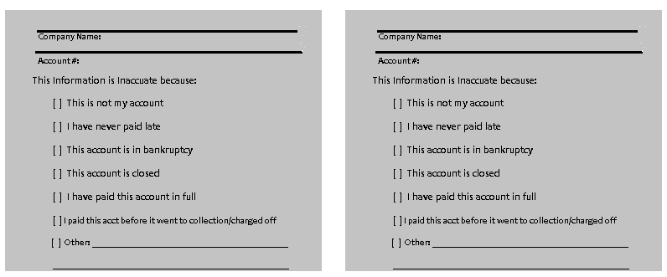

Step 3- Enter Previous Address/Employer Corrections and Additional Comments (Optional)
Please use this space for corrections to your previous address information, corrections to your previous employer information and for additional comments.

Signature: ______________________________________________________________________ Date:___________________

Step 4- Return this form via fax to:
CtCredit.net
Fax: 877-369-1727

Note: If you have any documentation supporting your request (i.e letter from credit, court, etc.), please fax a copy of that along with this request.

